Social media has become a standard form of communication in our lives. More and more we are seeing companies use social networking sites to advertise their goods or services. But is social media an effective tool to use for advertising and marketing? Yes, it is. Let’s discuss some reasons why companies should be using social media to market themselves and advertise.
Social media has become central to many people’s lives. “Over the past year, more than half of consumers (54%) say their use of social media has grown, and perhaps unsurprisingly, Gen Z and Millennial consumers have seen the greatest surge in social media usage and expect it to keep rising” (Drenik, 2021). Social media is used by almost everyone you talk to. Chances are, even your grandma is using social media.
People can discover new brands on social media. In fact, “83 percent of Instagram users say they discover new products on the platform.” (McLachlan & Newberry, 2021). Brands can utilize social media in order to attract new customers. Because of how far-reaching social media is, new customers are constantly being introduced to a company through its social media. Social media can also help a business grow because social networking sites aren’t confined to one country or region, usually. Companies can gain an international following through their social media.
Social media is also relatively low cost. Nobody has to pay to create an account and it’s free to post things. Compared to traditional advertising such as tv commercials and billboards, using social media can save a company a lot of money. “There is one defining metric that defines the better option between traditional media and social media. This metric is cost per thousand impressions (CPM).” (Standberry, 2020). CPM is used to measure how much money is spent to reach a thousand customers. Below are the results of a comparison of different forms of advertising where the CPM was measured.
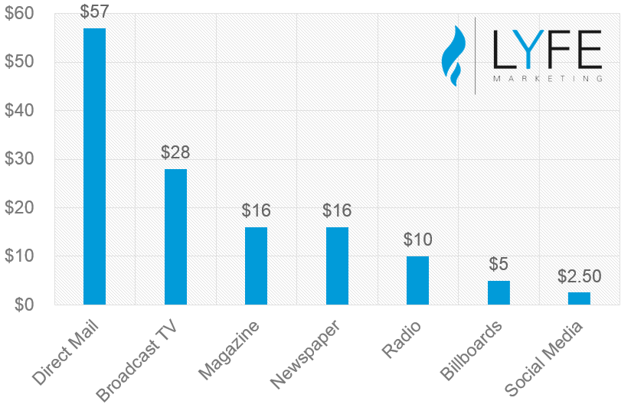

(Standberry, 2020)
The results of this chart shows that advertising on social media is more cost effective than other forms of advertising. So, companies can spend less and earn more by using social media. Now, this doesn’t account for social media marketing teams within a company which of course would cost money in the form of employee paychecks, maintenance budgets, etc. Companies can also outsource social media marketing teams as well.
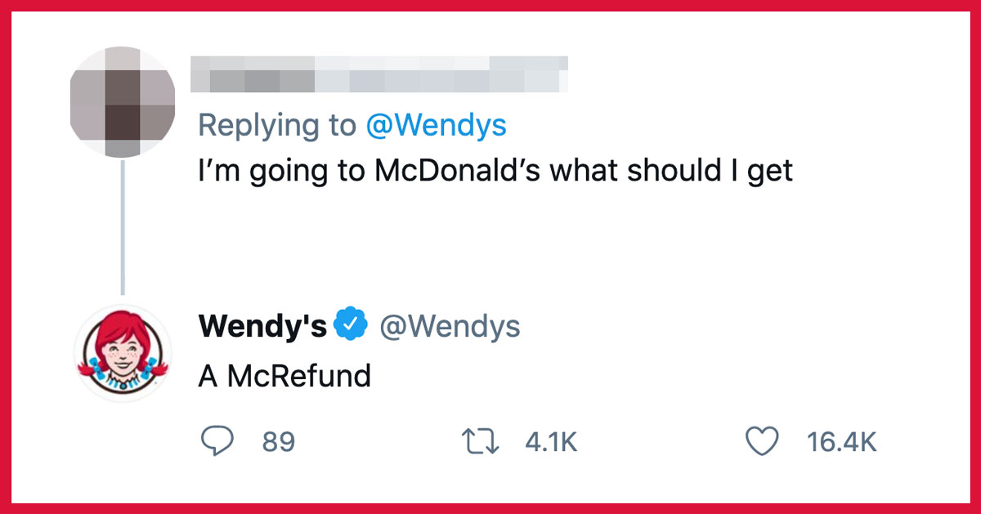
Social media can also help companies to have a connection with their customers. Social media allow people to connect with others in a way that feels intimate without actually being so. Brands can do this as well. On social networking sites like Twitter, companies can directly speak to their customers through tweets. A famous example of this is the fast-food chain Wendy’s Twitter account. The company is known for its humorous and unexpected tweets. “While humorous, sassy engagement may not be for every company, it’s hard to deny that roasting has become an effective focal point of Wendy’s social media reputation.” (McCall, 2021). When Wendy’s first started to tweet, they gained a lot of attention online for some of their comebacks. This attention helped the company to raise its brand awareness. They respond to people’s tweets mentioning them, whether good or bad. This type of interaction with costumers would not be possible without social media. The tweets get people talking, and that’s what advertisers want to see. Here is just one example of a classic Wendy’s roast on Twitter.
(Bingham-Smith, 2021)
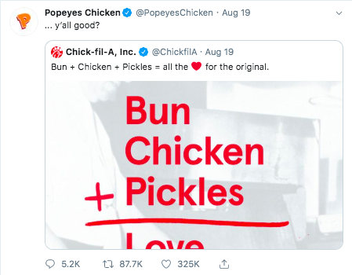
Another famous example of viral marketing on social media is the Popeye’s chicken sandwich. “On August 12, 2019, Popeyes took to Twitter to announce the launch of a new chicken sandwich to compete with its rivals KFC, Wendy’s and Chick-Fil-A. The launch nearly went unnoticed until Chick-Fil-A tweeted about having the original chicken sandwich—which inadvertently gave Popeyes launch a boost. Soon after Chick-Fil-A’s tweet, Popeyes tweeted back, saying “y’all good.” This tweet garnered 85,000 retweets and 300,000 likes” (LMD Agency, 2019). Then Wendy’s got involved by tweeting out a response and suddenly a back and forth was going on between all of the fast-food chains that had a chicken sandwich on their menu. Thus, the chicken sandwich wars began. Popeye’s quickly ran out of chicken sandwiches because everyone was scrambling to buy one to see what all the hype was about. It became a frenzy. Everyone had to try the sandwich. In my opinion, the sandwich was good, but not amazing enough to garner this type of clamor for it. The reason for the success of Popeye’s chicken sandwich was the social media reaction to the sandwich and the craziness surrounding it. The type of mass hysteria helped the company to sell more chicken. “Popeyes estimated that it earned between $20 million to $23 million from its new chicken sandwich.” (LMD Agency, 2019). All of that money was earned, because of a few feuding tweets.
(Hanson)
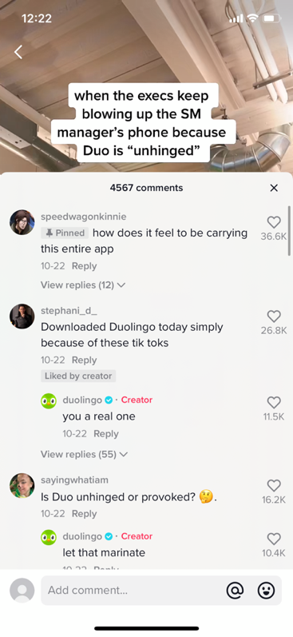
A newer social media that brands are beginning to explore is TikTok. A social media app that lets users post short videos and others can watch and like them. Trends are very common and replicated thousands of times. Brands have created their own accounts and are doing social media marketing on the app. A company that has recently been getting a lot of attention on the app is Duolingo, a language learning app. The comapny already had a green owl as its mascot, and so when they started making videos on TikTok they had an employee dress up as the mascot and film videos. “From clips of Duo jokingly chasing employees through the space to clapbacks in reply to users saying they prefer Google Translate to a mild obsession with Dua Lipa, the company’s social media coordinator Zaria Parvez has helped Duolingo’s TikTok go from around 50,000 followers to over 1.3 million in a matter of weeks.” (Burkholder, 2021). There had already been internet jokes about the app and it’s sometimes aggressive reminders that you haven’t practiced your Spanish yet. So, when the company started making these TikToks, with a mascot who was being sassy and aggressive people loved it. It fit with the brand’s reputation really well. There have even been comments on their videos saying things like “I downloaded Duolingo just because of these videos”. Their viral marketing worked, and people have started to use the app even though they had no real desire to learn a new language.

(Duolingo, 2021)
How can companies use social media effectively? First, they need to post consistently. “You want your followers to know what to expect from you, so follow a consistent posting schedule. This will also help you avoid posting too much, which can be off-putting for your followers.” (Kuligowski). Second they need to “Provide fun ways to generate more leads and engage with your customers, like running contests, linking to your website or special offers in your profile bio, and hosting live videos” (Kuligowski). Third companies should use analytics to learn who their audience is or who they want it to be. “Knowing what your audience wants to see from you and responding accordingly can go a long way in boosting your engagement rates.” (Kuligowski). Lastly, they need some kind of plan. How they want to present themselves online is the most important aspect of social media marketing. They can control their image on social media so they need to make sure they have it planned out ahead of time.
Social media is a cheap, easy, and fun way for companies to market themselves and advertising their services or products. Companies should be taking advantage of social media like the three examples shown above. They can reach a lot more people, it’s more cost effective than traditional forms of advertising, and it’s helps to establish a connection with its costumers.

Works Cited
Bingham-Smith May 28, K. (2021, May 28). Whoever runs Wendy's twitter account is a damn comedic genius. Scary Mommy. Retrieved November 19, 2021, from https://www.scarymommy.com/wendys-twitter-account-pure-gold/.
Burkholder, S. (2021, November 8). Thanks to duolingo's big green owl, the edtech company is now one of the most viral brands on TikTok. Technical.ly Pittsburgh. Retrieved November 19, 2021, from https://technical.ly/pittsburgh/2021/11/08/duolingo-tiktok/.
Duolingo [@duolingo]. (October 10, 2021) [Video] TikTok https://vm.tiktok.com/TTPd2BdBFT/
Drenik, G. (2021, April 22). Businesses are increasing their investments in social media as consumers use social media more than ever before – here's why. Forbes. Retrieved November 18, 2021, from https://www.forbes.com/sites/garydrenik/2021/04/22/businesses-are-increasing-their-investments-in-social-media-as-consumers-use-social-media-more-than-ever-before--heres-why/?sh=29172067156f.
Hanson, A. (n.d.). It's time to call the Popeye's tweet a huge social media win. Business 2 Community. Retrieved November 19, 2021, from https://www.business2community.com/trends-news/its-time-to-call-the-popeyes-tweet-a-huge-social-media-win-02238068.
Kuligowski, K. (n.d.). Marketer's Guide to Social Media. Business News Daily. Retrieved November 19, 2021, from https://www.businessnewsdaily.com/7832-social-media-for-business.html.
McCall, K. (2021, March 3). What you can learn from Wendy's social media strategy . Rival IQ. Retrieved November 18, 2021, from https://www.rivaliq.com/blog/wendys-social-media-strategy/.
McLachlan, S., & Newberry, C. (2021, June 29). 22 benefits of social media for business. Social Media Marketing & Management Dashboard. Retrieved November 18, 2021, from https://blog.hootsuite.com/social-media-for-business/.
Standberry, S. (2020, August 5). Traditional media vs. social media advertising - cost comparison. LYFE Marketing. Retrieved November 19, 2021, from https://www.lyfemarketing.com/traditional-media-versus-social-media/.
What the chicken sandwich wars can tell us about viral marketing. LMD Agency. (2019, November 1). Retrieved November 17, 2021, from https://www.lmdagency.com/blog/2019/what-the-chicken-sandwich-wars-can-tell-us-about-viral-marketing.

